Hip-Shoulder Separation Validation Research

Hey all! I just wanted to update you guys on what I’ve been up to after graduation! So far this summer, I’ve been waiting (and still waiting) for my OPT to be approved while also actively looking for work. With a decent amount of time on my hands, I decided to do a little personal project on my own.

When Driveline Baseball released the OpenBioMechanics project, I knew I wanted to use the data and the skills I learned from my Master’s Degree to create something that could benefit me and the baseball community as a whole. But when I looked at the data, it was tough for me to initially understand them. I have experience with handling big data and the training aspect of baseball, but I have little experience with biomechanics. There are different body parts, directions, and axes that need to be considered.

Another challenge for me is to come up with a problem in baseball that can be solved using these data. It took a lot of brainstorming but I decided that I wanted to validate the concept of hip-shoulder separation in hitting. I thought that I could do this by using the “joint velos” data and looking at how fast each body part is moving over the time of a swing (particularly the lead hip, rear hip, lead shoulder, rear shoulder, torso, and pelvis).

I focused on those body parts because according to a Driveline article, “Hip-shoulder [separation happens in the swing when the hips begin rotating towards the pitcher while the torso gains counter-rotation](https://www.drivelinebaseball.com/2019/10/hitting-concepts-visualizing-the-why-behind-hip-hinge-hip-torso-separation-and-maintaining-spine-angle/)”. The article stresses the importance of the hip and torso working counteractively while the pelvis stays stacked by the hitter hinging. I also added the shoulder because I wanted to see how it moves relative to the other three body parts and if the torso, pelvis, or hip would relatively fire first before the shoulder. By focusing on these body parts, I thought that we could see separation happening more clearly.

So I got to work and tried different ways to show hip-shoulder separation with the data. I ended up deciding to look at singular swings and how those body parts performed over time. Before trying to visualize the swing, I needed to deal with the different dimensions of which direction each body part is moving towards (we have the x, y, z planes that were captured for each body part). I did a bit of research and with some mathematical background, I could use the Euclidean norm to calculate the magnitude of the angular velocity vector. This way, it will give me the overall angular speed, which would help me visualize the swing better. This is done by square rooting the sum of each vector squared.

After calculating the Euclidean norm of the body parts I wanted to focus on, I decided to plot some swings to see the overlap of different body parts and how fast they’re moving over time. I also included the contact time in the graph so I could imagine the swing better from the graph. And as you can see, there are separations in how each body part moves in different parts of the swing. Even though the graph shows some separation, it is still tough to understand since there isn’t a concrete pattern. Then, I thought that if we look at the peaks of the different body parts on the graph, we can generalize that the peaks capture the moment when each body part is moving the fastest and firing in the swing. After realizing this, I decided to add markers to the peaks of each body part. This is what it looks like:

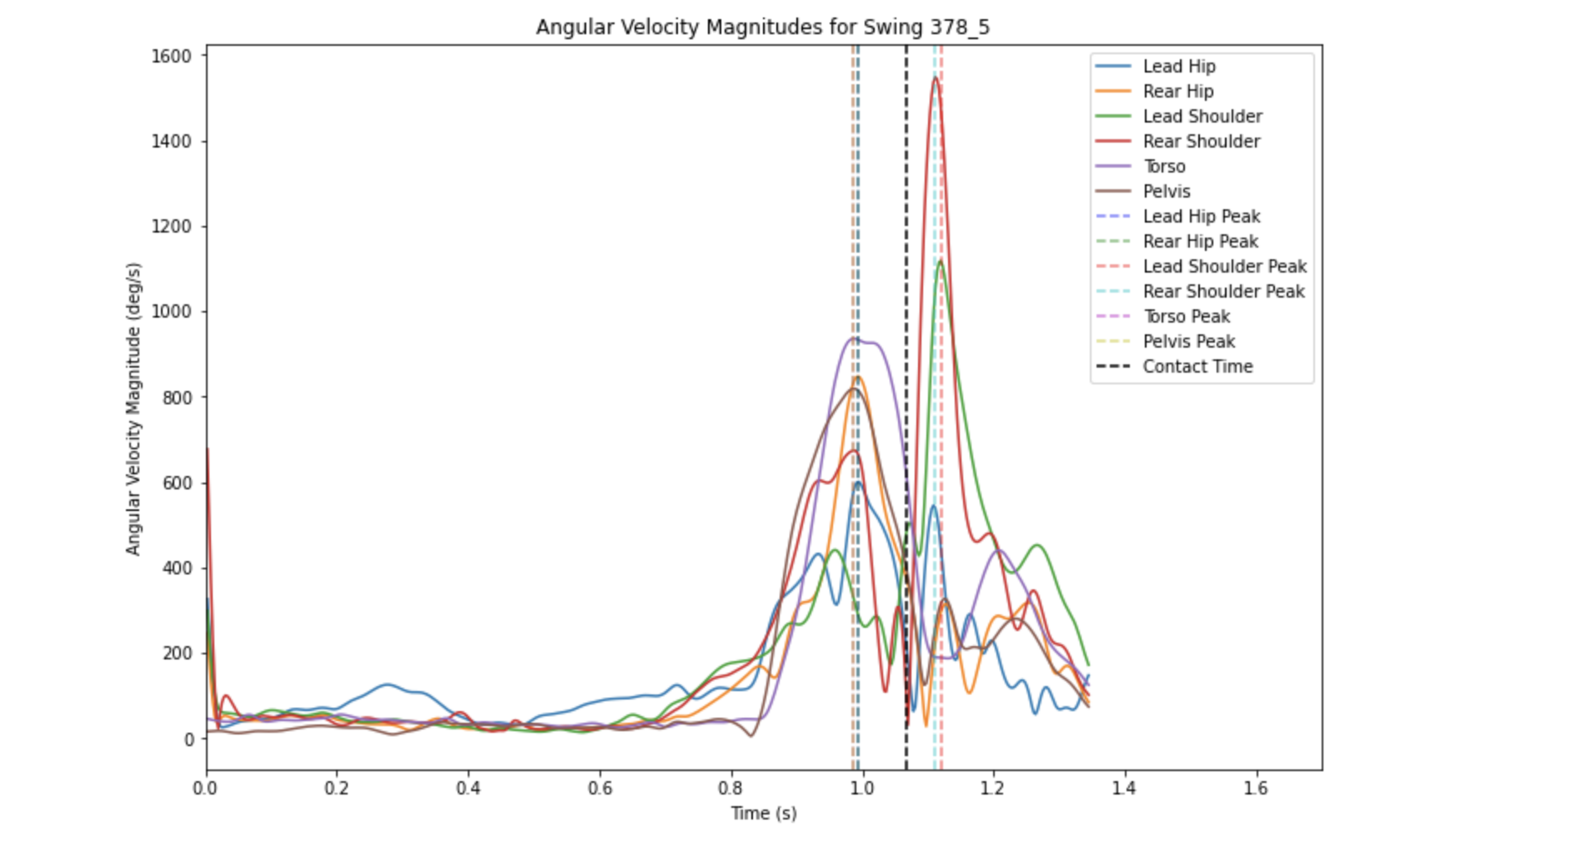

So now, we can all see that the peaks are separated, and different body parts are firing at different times. Keep in mind though that the swings are captured within less than 2 seconds, so technically the separation happens almost instantaneously (the difference is just in milliseconds). Nonetheless, there is still a separation between each body part. You can also see the order of which body parts would fire first to the last. I think we can use the order to picture the swing a little better and see which body part usually fires first till the last to get a better understanding of the components of a swing. To do that, I decided to get the order of the peaks of each body part for 50 random swings, then get the mean order for each body part to find which body part usually fires first and last. And this is what I got:

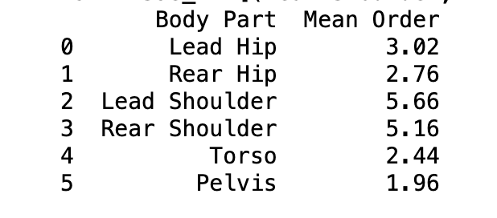

Now that I got the mean order, there are different ways that you can use this information. When you look at the results, it says that the pelvis fires first, then the torso, rear hip, lead hip, rear shoulder, then lead shoulder. A coach may think that since the pelvis fires first usually in those 50 swings, we would need to train hitters to focus on firing that body part first. This may work for some hitters, but not all. In my experience, every hitter has different feels and cues that may not even be directly correlated to how the hitter swings (a real-life example from my own experience is if I try to feel my hip hinge more, my hip would not fire and my torso would move first since I don’t load it properly when I think about that).

However, the data does show that hip-shoulder separation exists within the swing. Different body parts are firing at different milliseconds. And we can say that training hip-shoulder separation when we want to improve on hitting would be beneficial. Since the separation happens almost instantaneously, it would be tough for humans to train it directly. Trying to ‘feel’ the separation and force it to happen would be unnatural and slow. Instead, from my experience we would use drills to train our bodies to do that movement without directly. What worked with me to get this feeling of hip-shoulder separation would be a drill I got from Driveline called the hook ‘em drill. This drill helped me feel like I didn’t open up early with my shoulder and can stay closed long enough until my hips and pelvis fire. This is shown in this video:

[Hook ‘Em | Hitting Drills | Driveline Baseball](https://www.youtube.com/watch?v=IyCE0hey7-I)

The baseball swing is a lot more complex than just hip-shoulder separation. Other factors do affect a swing (where the ball is pitched, the hitter’s timing, etc). But I think it’s still beneficial for us hitters to understand how hip-shoulder separation works and how to train it, let alone break down different swings to show that it exists.

There are a couple of limitations/things to consider when looking at this project. From OBP, the data I used did not consider where the pitch is thrown, what the batter’s bat path looks like, or even the swing result. This causes the peaks and mean order I calculated to be slightly different every time I run the code since it could grab 50 different swings that can have different mean orders due to some swings being completely different from one another.

Another thing to consider is that 50 swings might be too low to generalize a swing. Whenever I run the code to get the mean order, I get results that are different multiple times. Now I could try to include more swings by altering the code, but I’ll need more computational power for it to run faster. It’ll take longer the more swings I include since the data frame has a lot of data entries due to it capturing different milliseconds of the swing it. The optimal sample size would be to use every single swing, but I tried that and it crashed my program. Next time, trying a bigger sample size with more swings could be beneficial to improve the quality of the experiment.

Lastly, I wanted to find a way to validate the accuracy of the mean orders. I tried doing the standard deviation of the mean orders to see variability, but I still think it’s not enough for me to validate the experiment (due to the lower sample size). Overall though, I think the experiment was successful. We can see separation happening in the graph and how the peaks of different body parts are staggered. We need to keep in mind that there is more to a swing than hip-shoulder separation, but it’s still beneficial so we can understand how we move better throughout our swings. To further this experiment, I plan to try and correlate bat speed with hip-shoulder separation since I’ve now attempted to validate it. This way, we could validate how hip-shoulder separation is beneficial for hitters to understand and train for (since bat speed is one metric that we could work on with hitters to make them better).

Sources:

<https://www.studysmarter.co.uk/explanations/physics/classical-mechanics/3d-euclidean-space/#:~:text=3D%20Euclidean%20Space%20is%20a,like%20points%20and%20straight%20lines>.

<https://www.drivelinebaseball.com/2019/10/hitting-concepts-visualizing-the-why-behind-hip-hinge-hip-torso-separation-and-maintaining-spine-angle/>

<https://chatgpt.com/c/e68c5681-6e5a-4b4a-9b26-7599e9950c3c>

<https://www.openbiomechanics.org/>

<https://github.com/drivelineresearch/openbiomechanics/blob/main/baseball_hitting/README.md>